**COMPUTATIONAL LOGIC**

**PROPOSITIONAL LOGIC**

**The syntax** introduces the entities used to define well- forms propositional formulas

**Vocabulary** = set of propositional variables + connectives + truth variables

**Connectives**:

* Negation (the only unary connective): **⌐**
* Conjunction: **ꓥ**
* Disjunction: **V**
* Implication: **→**
* Equivalence: **↔**
* Nand: **↑** (negation of conjunction)
* Nor: **↓** (negation of disjunction)
* Xor: **Å** (negation of implication)

Order: **⌐**, **ꓥ**, **V**, **→**, **↔**

$F_{p}$ = set of well-formed formulas built using the propositional variables, connectives and parentheses

**Aim of semantic** = to give a meaning(T/F) to the propositional formulas

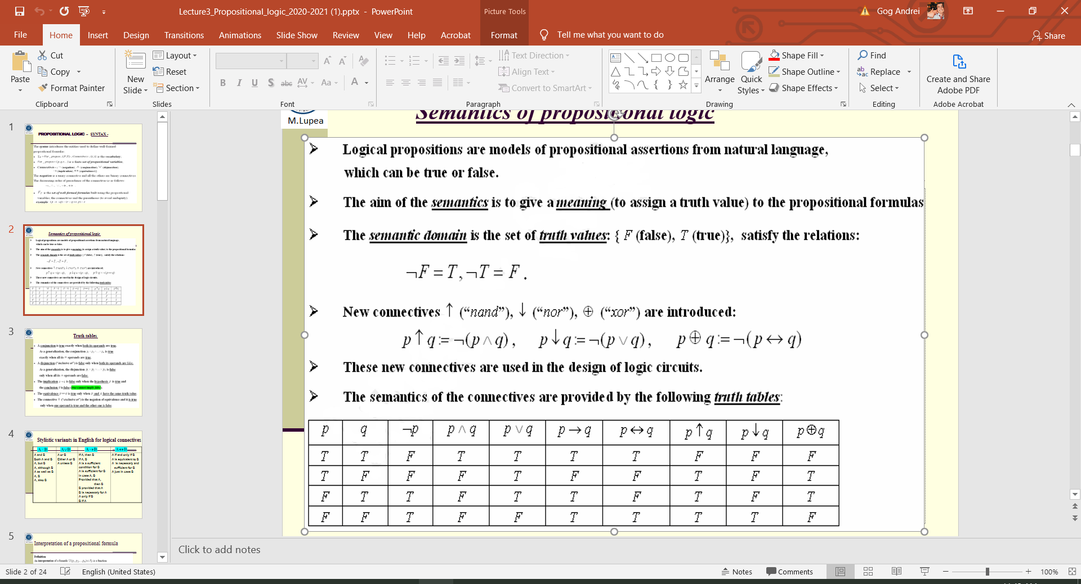**Semantic domain** = T (true) + F(false)

**Conjunction** = true when all variables are true

**Disjunction** = false when all variables are false

**Implication** = false when the hypotheses is true and conclusion is false (True can’t imply false)

**Equivalence** = true when variables have the same truth value

**Interpretation (of a formula)** = is a function i: {$p_{1}, p_{2},… p_{n}$} → {T, F}

i(⌐p) = ⌐ i(p) i(p ꓥ q) = i(p) ꓥ i(q) i(p V q) = i(p) V i(q)

i(p → q) = i(p) → i(q) i(p ↔ q) = i(p) ↔ i(q)

A formula has $2^{n}$ interpretations

An interpretation assign truth values to propositional variables and using the semantics of the connectives evaluate formulas assigning truth values to them

**Model** = an interpretation i which evaluates a formula as true

**Anti-model** = an interpretation i which evaluates a formula as false

**Consistent formula** = a formula that has a model

**Valid formula** (tautology) = a formula that has only models

**Inconsistent formula** = a formula that has only anti-models

**Contingent formula** = a consistent formula, but not a valid one

**Logical consequence** = U**|=**V

**Logical equivalent** = identical truth tables U**≡**V

**Meta-symbols**: **|=**,**≡**

Simplification laws: Commutative laws

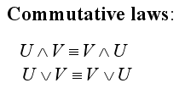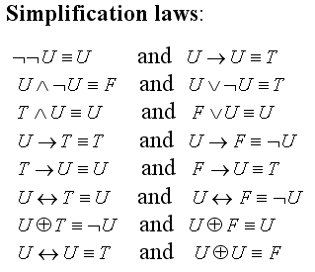

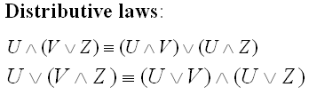 Distributive laws